**ASSIGNMENT – 1**

**Subject: CSW2 (CSE 2141)**

**Name: Arpit Kumar Mohanty**

**Registration Number: 2341013237**

**Section: 23412G1**

**Branch: CSE**

**Q1. Write a Java program with a Car class having private fields (make, model), a parameterized constructor, getter, and setter methods. In the CarTester class, instantiate myCar1 with values and myCar2 with null. Print their initial details, update myCar2 using setters, and print the updated details.**

**Solution along with Output:**

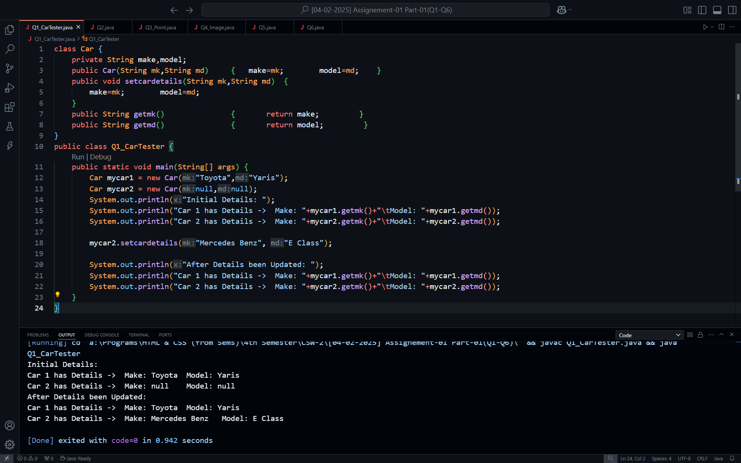

**Q2.** **Design a Java class called Rectangle with private attributes length and width. Include a constructor to initialize these attributes, as well as setter and getter methods for each attribute. Additionally, implement methods to calculate the area and perimeter of the rectangle. Write a main method to create an object of the Rectangle class, set values for its attributes, and display the area and perimeter.**

**Solution along with Output:**

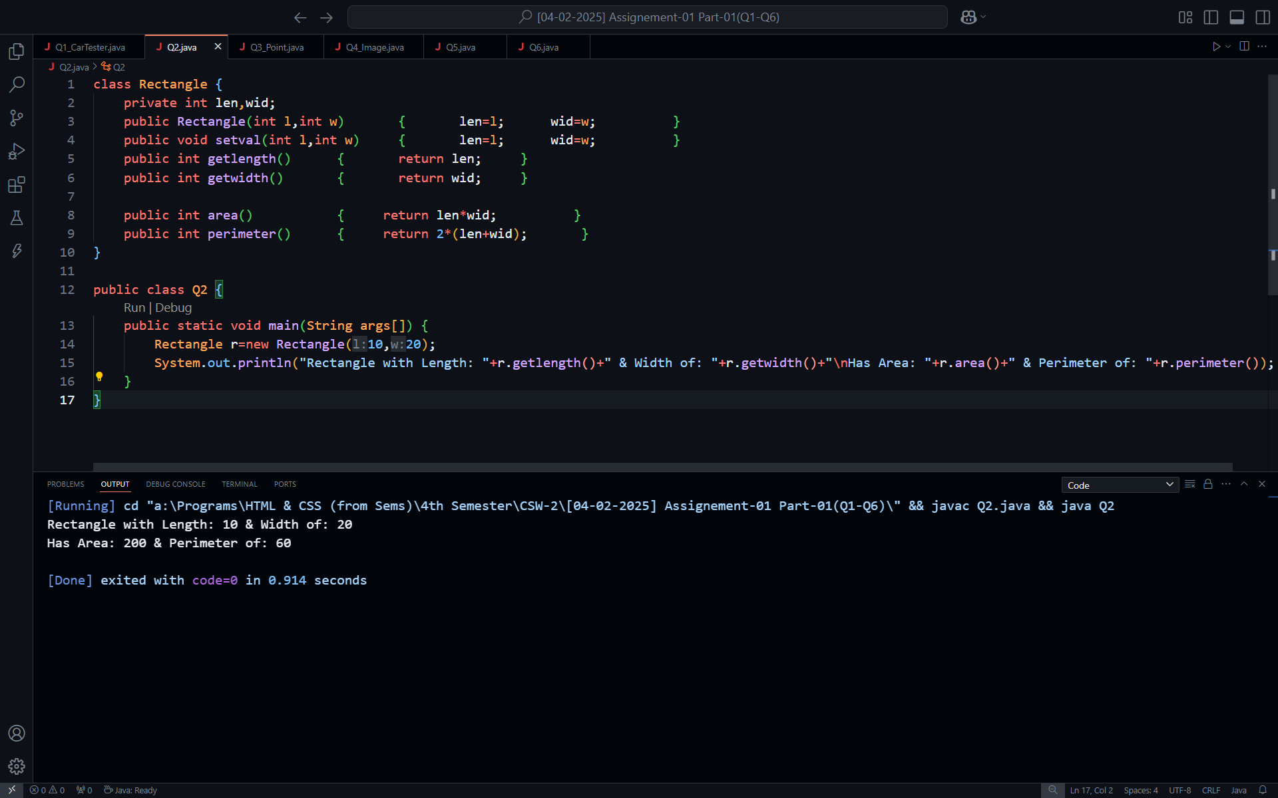

**Q3.** **Write a Java program that defines a Point class with attributes X and Y, and includes a parameterized constructor to initialize these attributes. Implement a copy constructor to create a new point object with the same attribute values. Ensure that modifications made to one object do not affect the other. Utilize getter and setter methods to retrieve and update the attribute values.**

**Solution along with Output:**

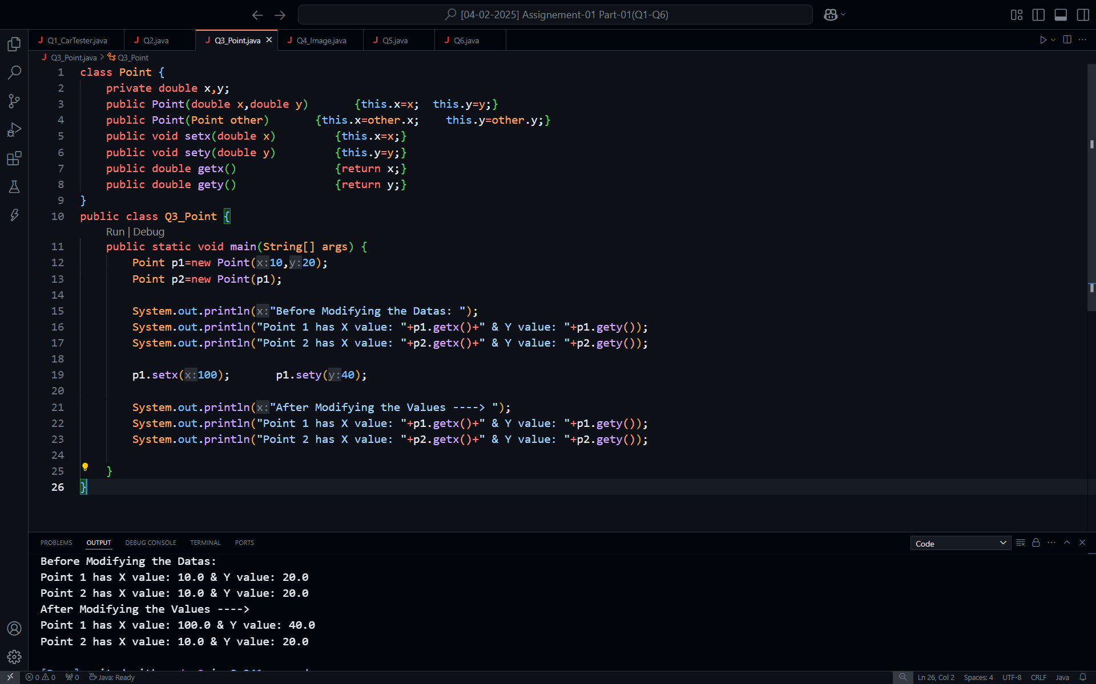

**Q4. Write a program to create an Image class with attributes imageWidth, imageHeight, and colorCode. Add the required constructor, set methods, get methods, and toString method. Create the object of the image class using the default and parameterized constructor and print the details of the object.**

**Solution along with Output:**

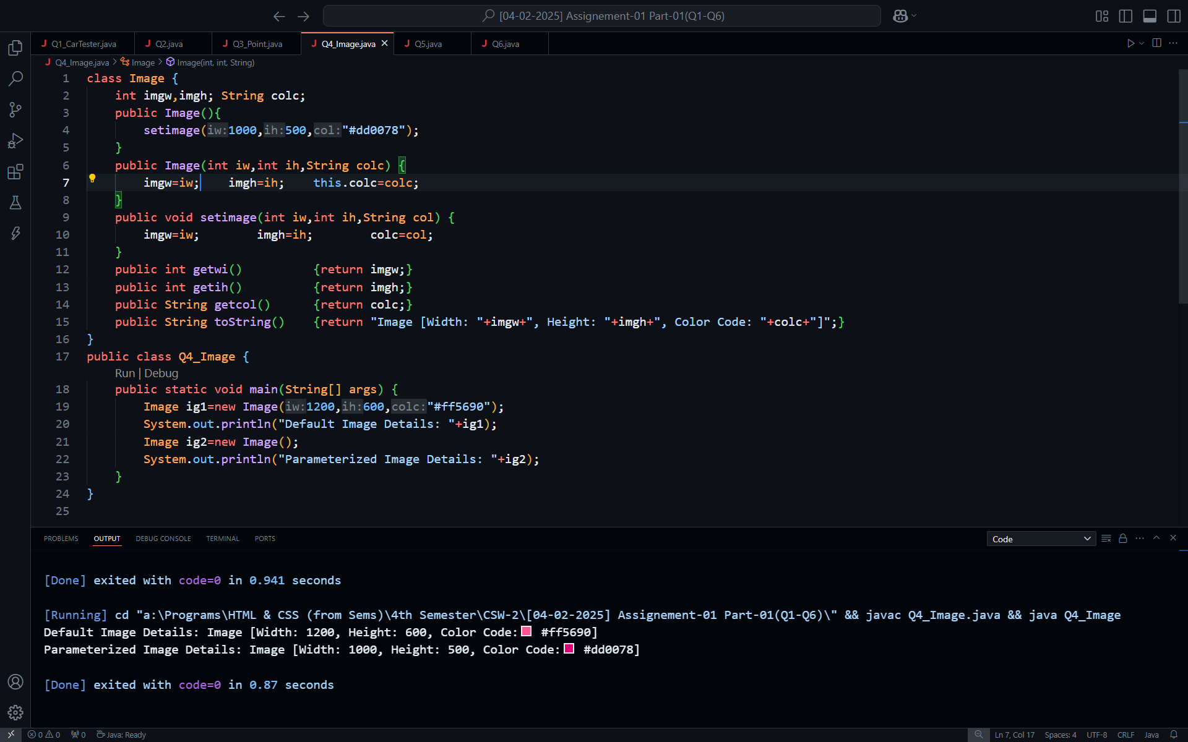

**Q5. Create an ImageLibrary, which contains a set of image objects (from Q4) and operations such as searching an image, inserting an image, and getting an image. Create an ImageController class to manage the program execution and call the methods to create and manipulate images.**

**Solution:**

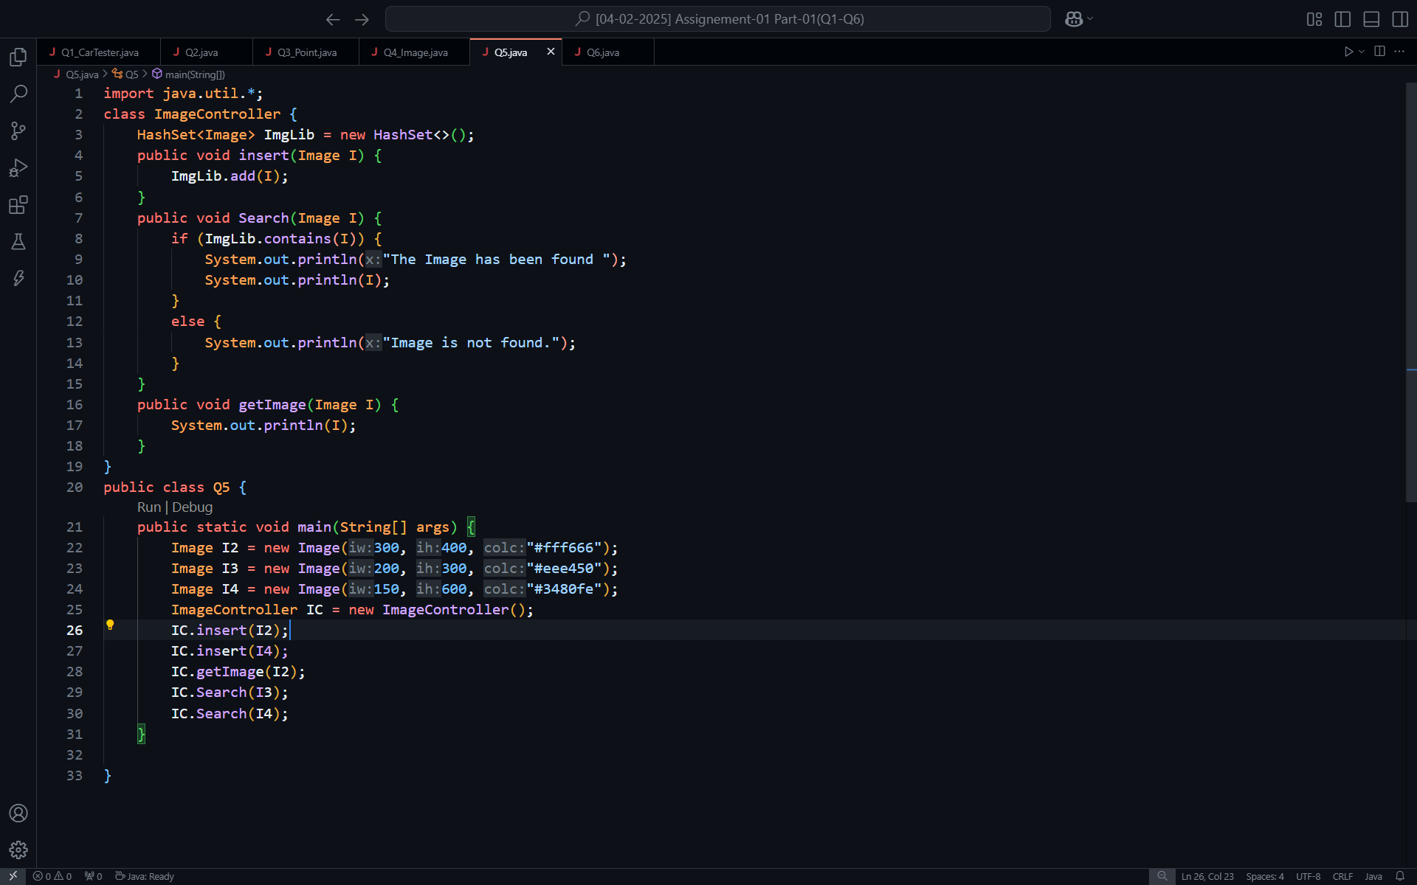

**Output:**

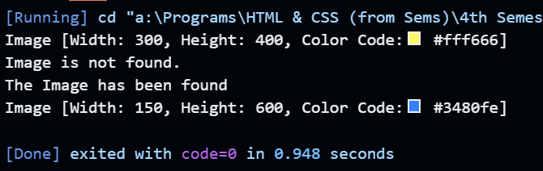

**Q6.** **Develop a Java-based College Management System to model the relationship between colleges and students. Create a College class with attributes collegeName and collegeLoc, and a Student class with studentId, studentName, and a reference to a College object. Implement a constructor in Student to initialize these attributes and a displayStudentInfo() method to print student and college details. In the MainApp class, instantiate at least two College and Student objects enroll each student in one of the colleges, and display all details using appropriate methods.**

**Solution:**

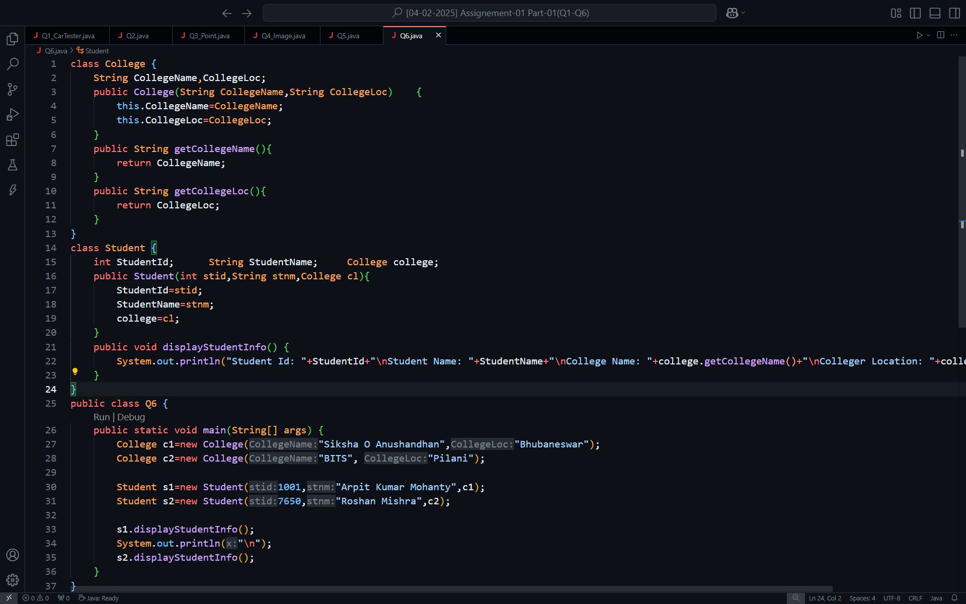

**Output:**

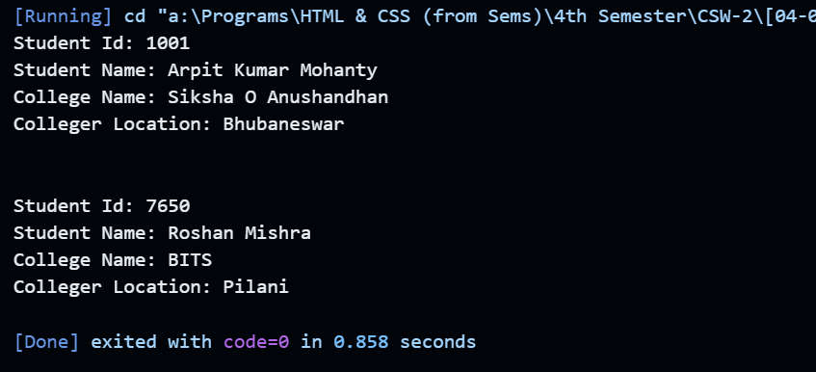

**Q7. Develop a Java program for a library system using encapsulation, abstraction, and inheritance. Create an abstract LibraryResource class with private attributes (title, author), a constructor, getters, setters, and an abstract displayDetails() method. Extend it into Book, Magazine, and DVD classes, each adding a specific attribute (pageCount, issueDate, duration), along with constructors, getters, setters, and overridden displayDetails() methods. In the LibrarySystem class, instantiate various resources and call displayDetails() to display their information.**

**Soution:**

**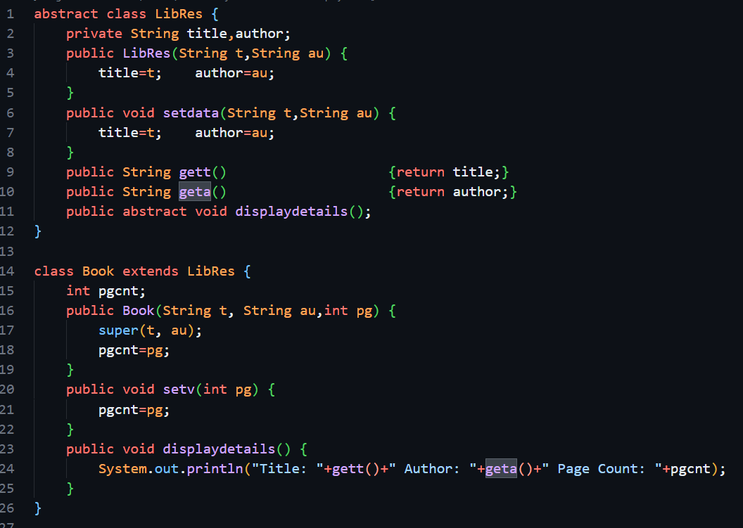  
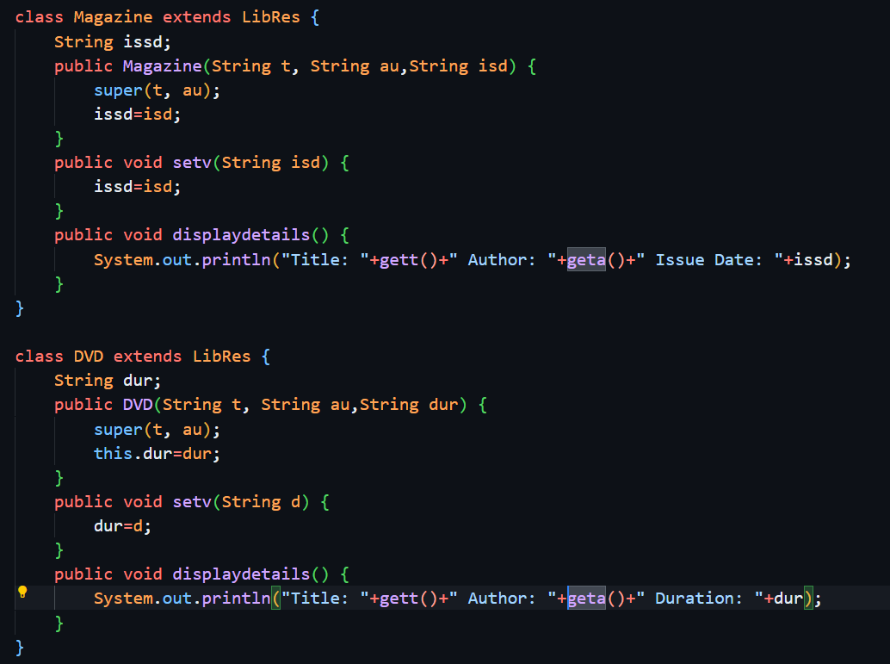  
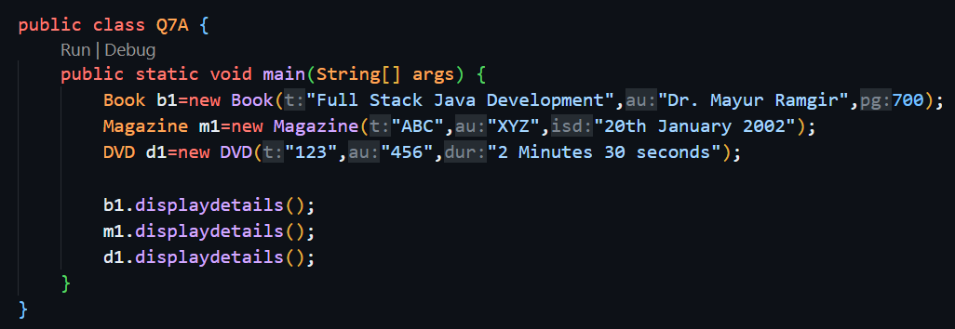**

**Output:**

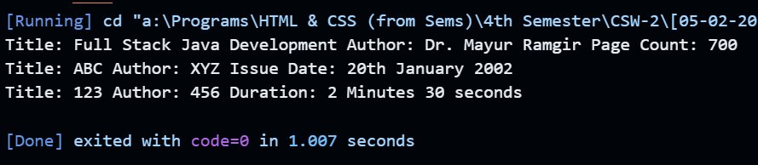

**Q8.** **Develop a Java banking application using polymorphism with three classes: Account, SavingsAccount, and CurrentAccount. The abstract Account class has private attributes (accountNumber, balance) and abstract methods for deposit and withdrawal. SavingsAccount adds an interestRate attribute, overrides deposit to calculate interest, and ensures sufficient balance in withdrawal. CurrentAccount introduces an overdraftLimit and overrides withdrawal to check this limit. In the BankingApp class, instantiate both account types, perform transactions, and display account details to demonstrate polymorphism.**

**Solution:**

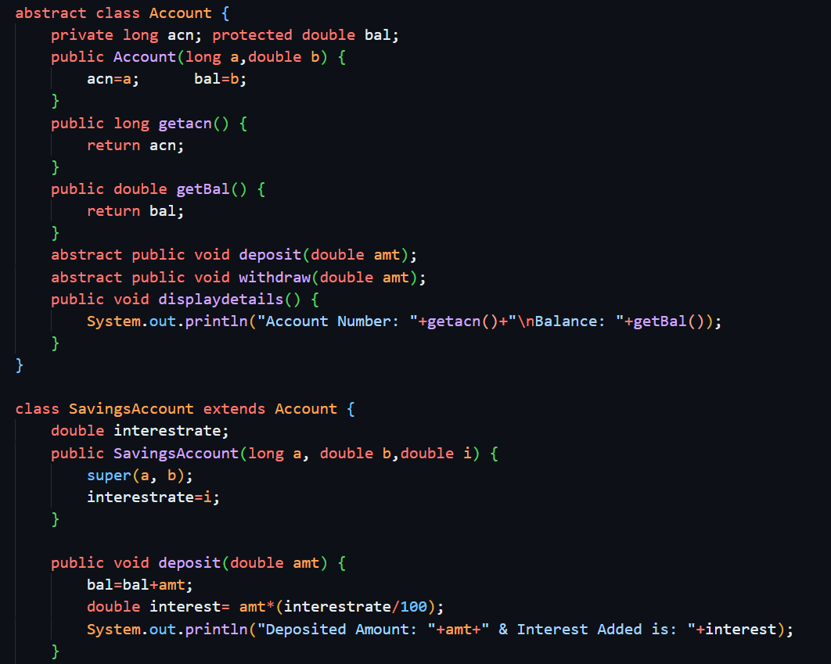

**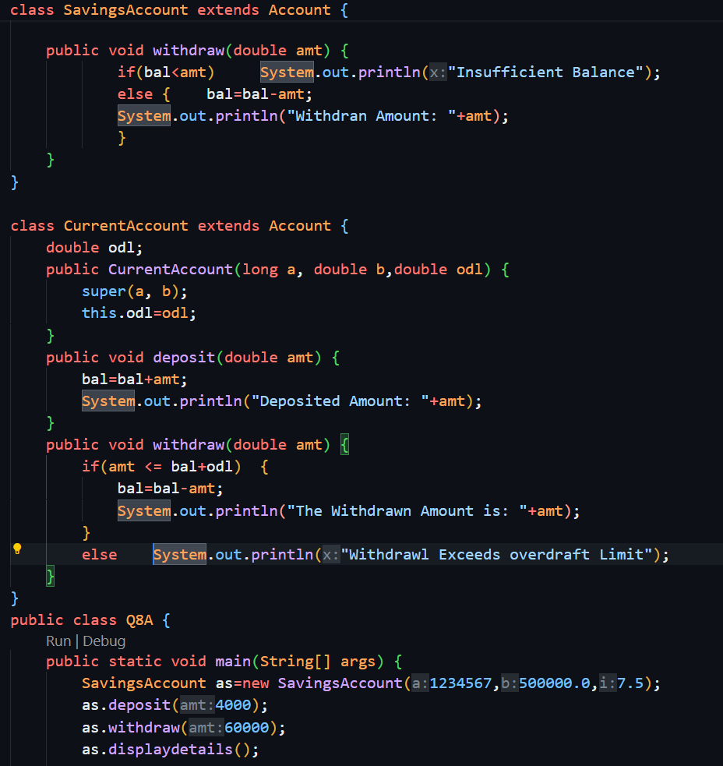  
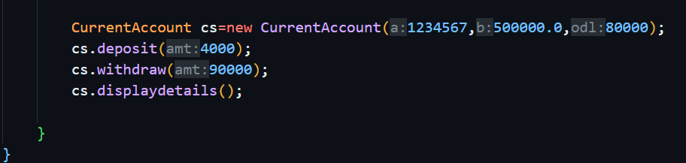  
  
Output:**

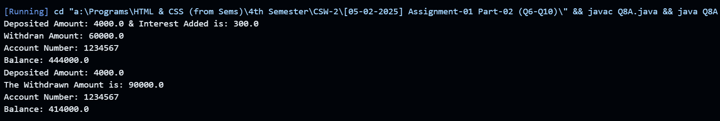

**Q9. Write a Java program demonstrating interfaces, method overriding, and method overloading. Define a Vehicle interface with abstract methods accelerate() and brake(). Implement Car and Bicycle classes that override these methods with specific messages for acceleration and braking. Introduce method overloading in both classes by defining multiple accelerate() methods with different parameters (e.g., speed, duration). In the VehicleApp class, instantiate Car and Bicycle objects, test overridden methods, and invoke overloaded accelerate() methods to showcase polymorphism.**

**Solution:**

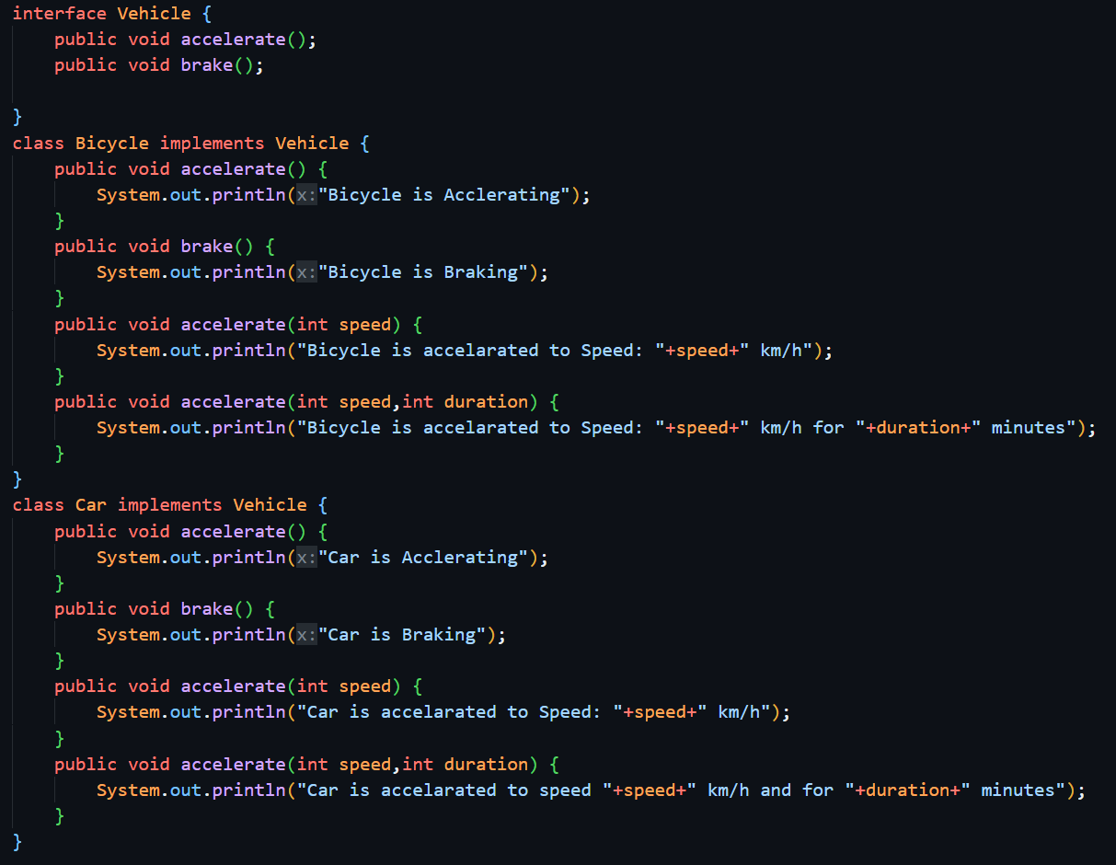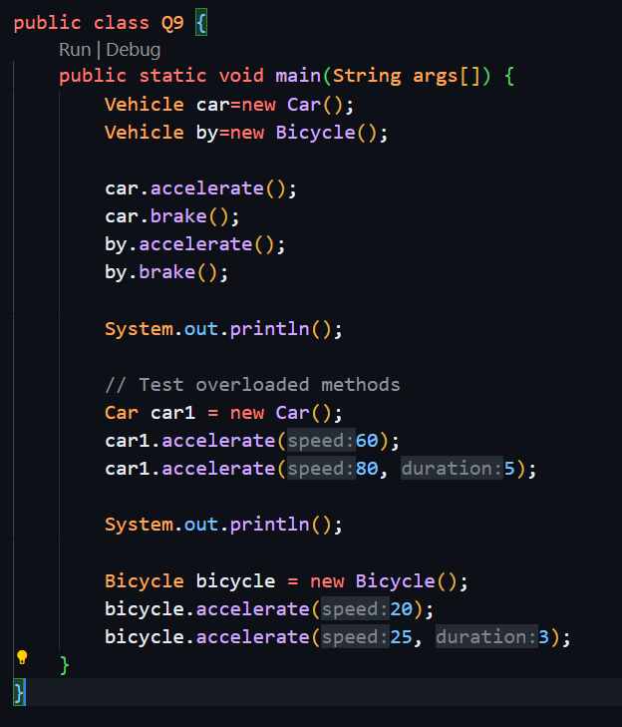

**Output:**

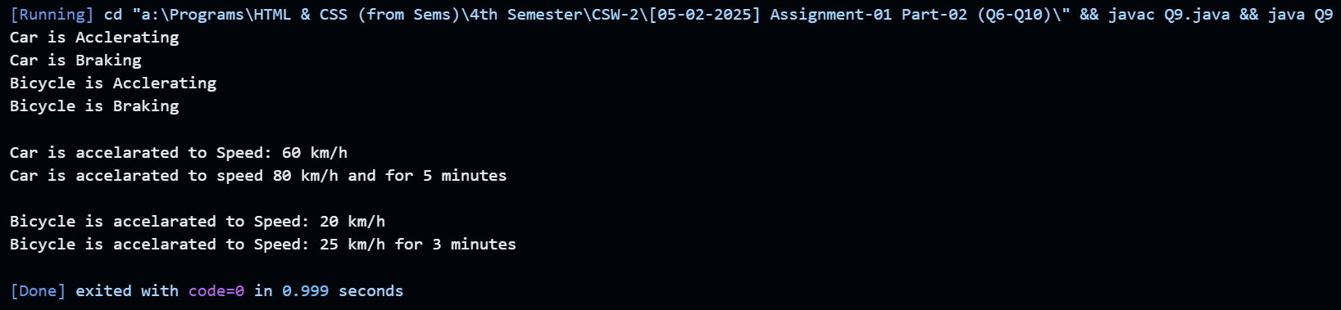

**Q10. Design a Java program for university student enrollment, ensuring loose coupling and high cohesion. Create Student and Course classes, and an Enrollment class that interacts with them through an EnrollmentSystem interface. Implement methods for enrolling and dropping students from courses, and displaying enrollment details. In the MainEnrollApp class, demonstrate functionality by managing student enrollments. Use comments to explain how the design maintains loose coupling (by relying on interfaces) and high cohesion (by keeping related functionalities within appropriate classes).**

**Solution:**

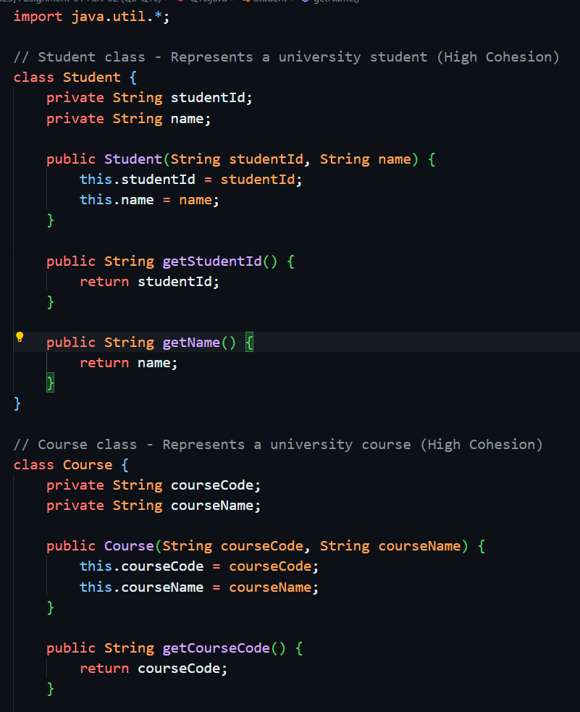

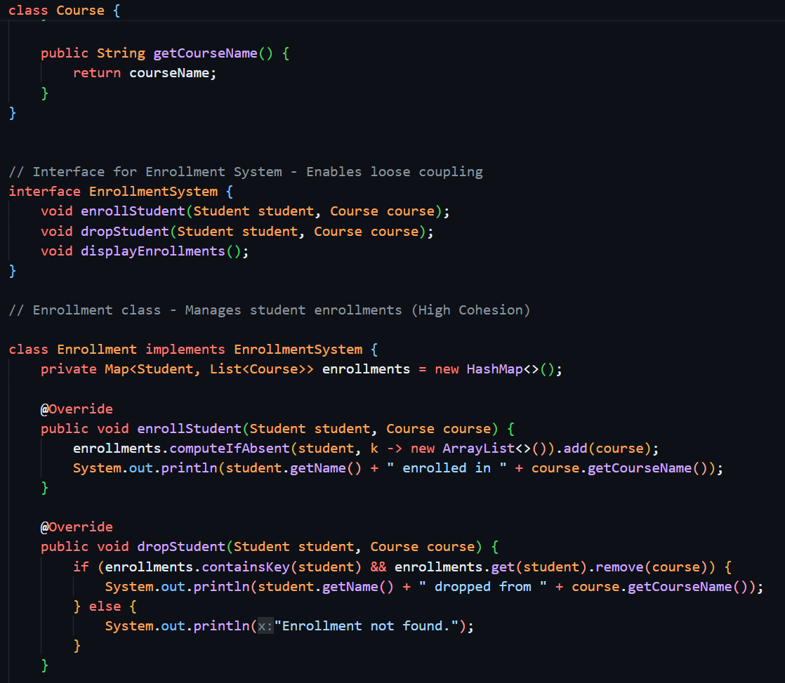

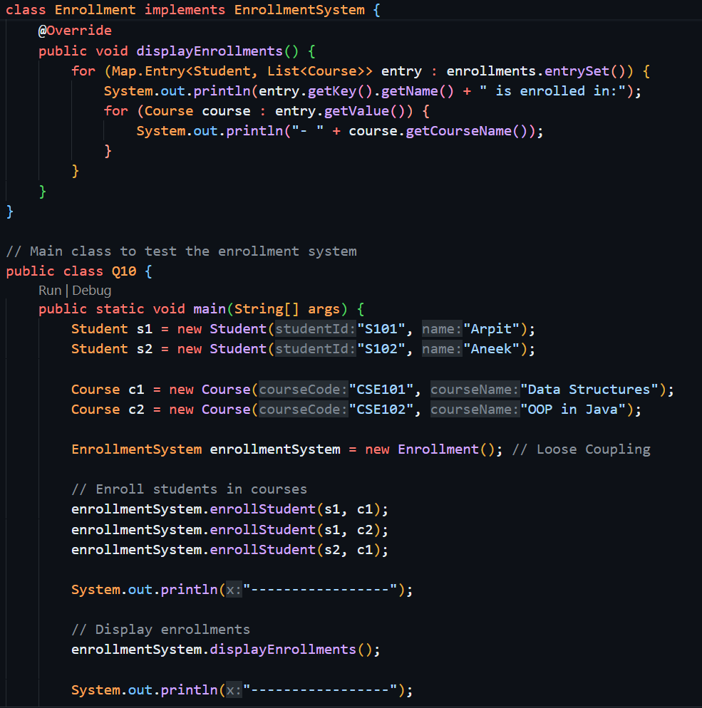

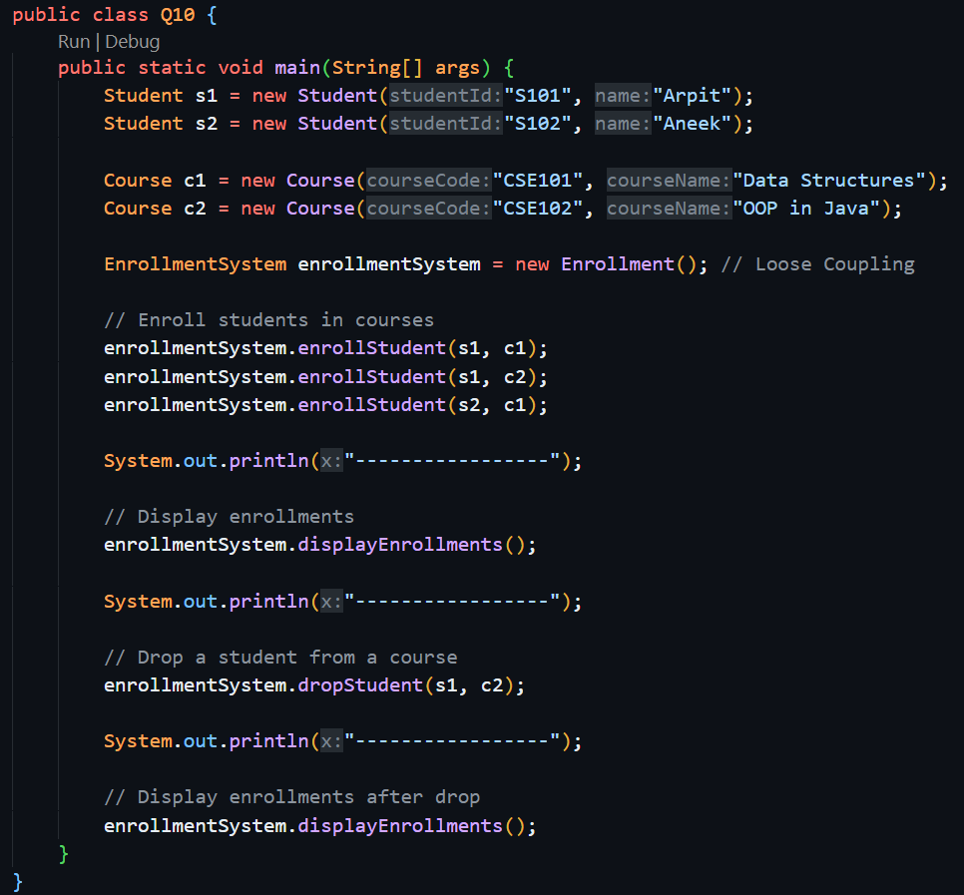

**Output:**

